COUNTERFEITING & UNFAIR COMPETITION

Our company has been making and marketing drill bits worldwide since 1953. DIAGER is a widely known name with international trademark protection since 1965.

“DIS TOOL” is currently the only company authorized to distribute DIAGER brand products in Egypt.

We have however discovered imitations of our product changing hands and unfair trading practice in the Egypt region. Investigations are under way and DIAGER will be seeking police action and taking legal proceedings against any infringement of our intellectual property rights.
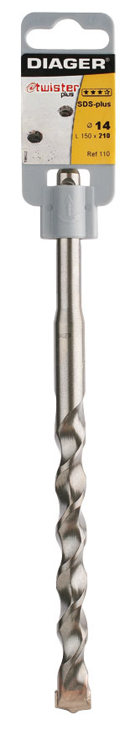
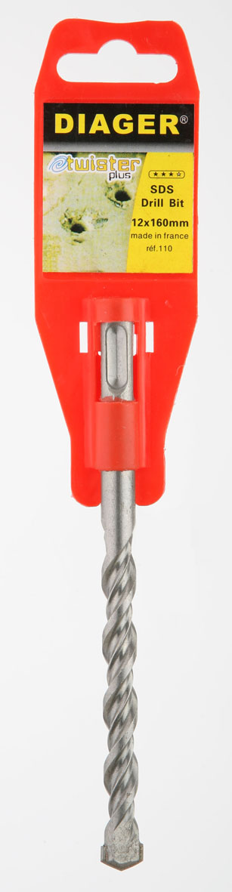

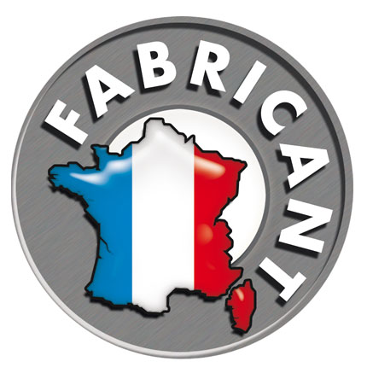
COUNTERFEIT PRODUCT CONTREFAIT
DIAGER PRODUCT



Counterfeiters risk punishment:


ARREST: HEAVY FINES, prison SENTENCES
+
LAW SUIT: dAmage AND intereSt
+
CUSTOMS SEIZURE OF FRAUDULENT PRODUCTS
+
PRESS DISCLOSURE
+
TRADING BAN
COUNTERFEIT PRODUCT

1
Shank meets worldwide standards
Poor quality shank

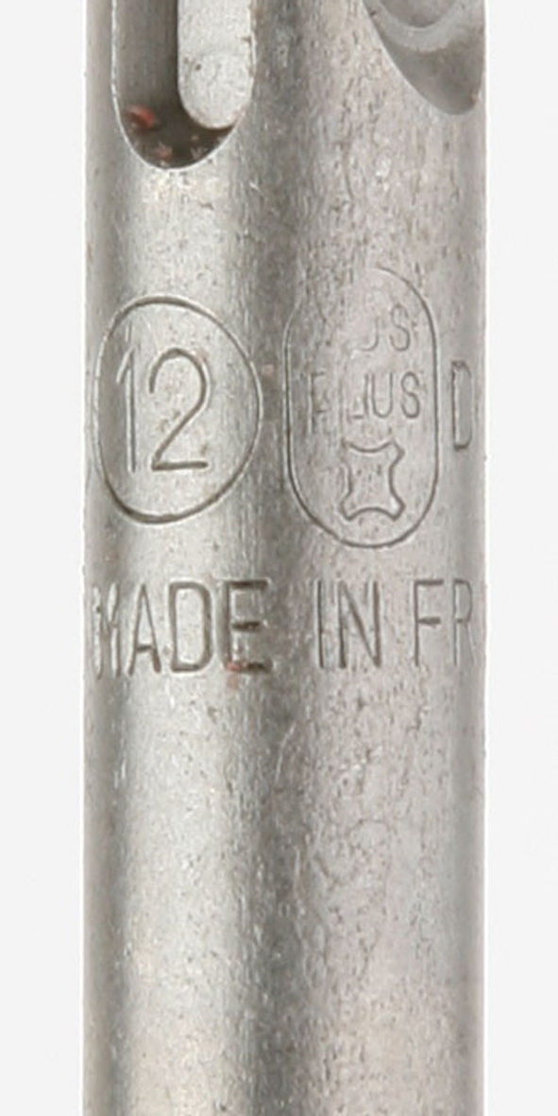

2
Unique DIAGER number “55” assigned by PGM®

NO DIAGER inscription

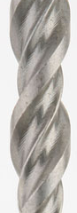
3
Patented helix for perfect swarf removal and fast drilling
NO TWISTER design helix

Tip: bad brazing, overhang, faulty centering
4
Concrete breaker tip with centering point. Perfect axis

ABOUT THE COUNTERFEITS:

COUNTERFEIT BRAND NAME AND PACKAGING:
a/ colour of the hanger: Red instead of DIAGER grey
b/ hanger design: Dimensions and shape different from DIAGER’s
c/ label: Blue and yellow for the word “TWISTER” instead of red.

Poor quality machining on the SDS+ shank
1
=> can damage your equipment

The imitation product does not carry distinctive DIAGER identification:
2
DIAGER enjoys a unique number “55” assigned by Prüfgemeinschaft Mauerbohrer
(PGM®) to its TWISTER PLUS drill bit. DIAGER is the sole company entitled to use this number. It is the PGM® guarantee of DIAGER quality in drill bits.

The imitation product uses a round helix whereas the real TWISTER has a specific square
shape. DIAGER’s square helix gives proven improvements in swarf removal and drilling time.
3
The steel quality of the imitation product is visibly low: scratches, surface irregularities, etc.

The tip brazing quality on the imitation product is poor: incomplete brazing, overhang, bubbles.
4
=> high breakage risk.
The tip on the imitation product is off to one side with respect to the axis of the bit:
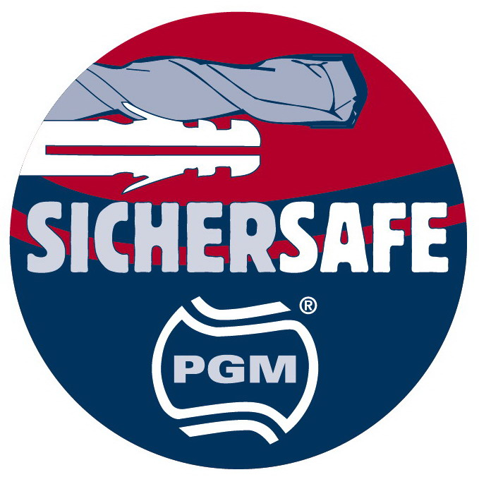
=> drilled hole diameter not PGM® compliant.

